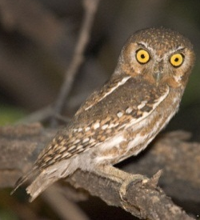
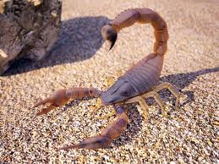
Endangered Species Post Production
Student name: _K. Adams_________ _Period:______All________
Common name: Elf Owl
Scientific Taxonomy: Kingdom Animalia, Phylum Chordata, Class Aves, Order Strigiformes, FamilyStrigidae Genus Micrathene, Species Micrathene Whitney
Attributes: Elf Owls do not have "ear tufts" or feathers on the top of their heads. Their feathers are grayish brown in color and eyes are pale yellow and are highlighted by thin white feathers that look like "eyebrows". The bill is gray with a horn-colored tip. In the wild, elf owls live 3-6 years. In captivity they usually live longer, between 6-10 years. Elf owls are about the size of a sparrow, Height: Males 16-24 cm (6.3-9.4 in), Females 18-24 cm (7.1-9.4 in) Weight: Males 166g (5.85 oz), Females 194g (6.84 oz)Wingspan Both: 48-61 cm (18.9-24.0 in)
Habitat: Sonoran Desert region in riparian (water) habitats or in areas where saguaro cactus are plentiful.
Diet: They mostly eat moths, crickets, scorpions, centipedes and beetles.
Predators or Prey: Elf owl predators can include other owls, snakes, coyotes, bobcats and ringtail, but most predators find it difficult to get to their nests which they built high up in saguaro cactus.
Location (where found?): They are found from the southwest USA to Central Mexico and Baja California. Northern populations winter in Central Mexico and on the Pacific slope north to Sinaloa, Mexico.
Population size: Global Population 190,000
Main Threat (Reason Endangered or Threatened):
The most important threat to the elf owl is habitat loss both of its riparian forest habitat and desert-scrub habitats. In Arizona they are not necessary threatened but numbers are decreasing steadily in California and Texas.
Adaptations:
Elf Owls owls have excellent night vision. Although they can't see in complete darkness they see well in low-light. Because they also have excellent hearing they have the ability to can catch their prey in complete darkness, by pinpointing it using their ears rather than eyes. Elf owls don't make any noise as they approach their prey because the sound of their wing beat is muffled by softened feathers on the leading edges of their wings.
List your information sources here:
Audubon Society - http://birds.audubon.org/species/elfowl-0
California Department of Fish and Wildlife - http://www.dfg.ca.gov/wildlife/nongame/t_e_spp/
Encyclopedia of life - http://eol.org/pages/1046661/details
Owl Research Institute - http://www.owlinstitute.org/elf-owl.html
Sonora Desert Museum - http://www.desertmuseum.org/kids/oz/long-fact-sheets/elf%20owl.php
