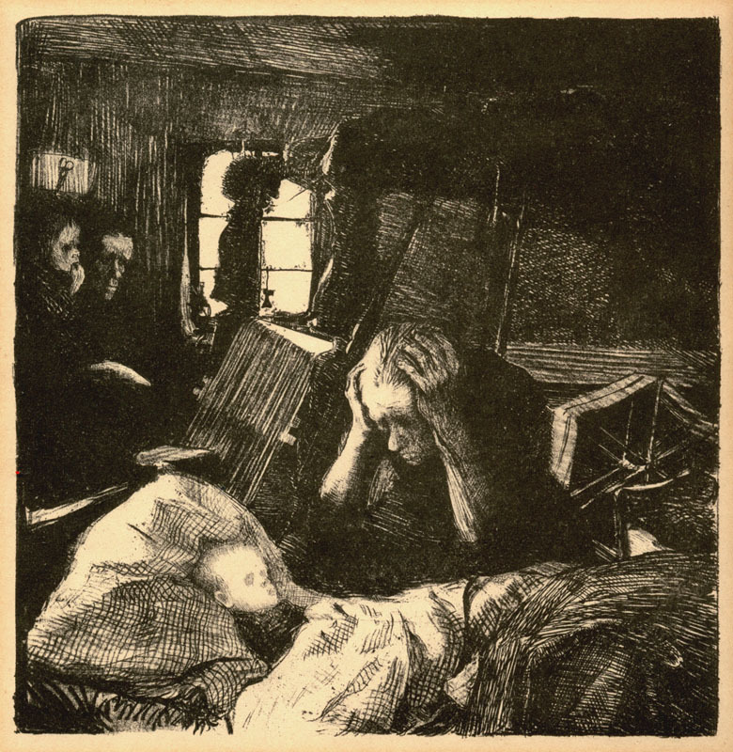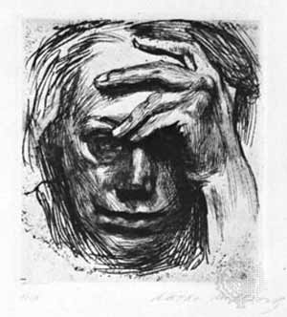xz

**Pre-Production:**

* Choose a social or ethical issue that you feel strongly about.
* Do 4 thumbnails on that subject

**Production:**

* Bring in own image or find reference
* Create own image with charcoal
* Work must strong contrast of value
* Imagery must reflect content.

**Post-Production**:

* “Title” Critique

**Links:**

<http://www.moma.org/explore/collection/ge/>

<http://arthistory.about.com/cs/nameskk/p/kollwitz.htm>

<http://www.britannica.com/EBchecked/topic/321437/Kathe-Kollwitz>

<http://www.femaleartists.org/kathe-kollwitz/>

Kathe Kollwitz:

Käthe Kollwitz original name Käthe Schmidt was born July 8, 1867, Königsberg in East Prussia [now Kaliningrad, Russia] and died April 22, 1945, near Dresden, Germany. She was a committed Socialist and humanist, fought against an unjust world with her eye and her hand. Her woodcuts, etchings, lithographs and charcoal drawings are starkly realistic, yet show sympathetic compassion for victims of war, poverty and hunger. Kollwitz’s first important works were two separate series of prints, respectively entitled Weavers’ Revolt (c. 1894–98) and Peasants’ War (1902–08). In these works she portrayed the plight of the poor and oppressed with the powerfully simplified, boldly accentuated forms that became her trademark. Though often categorized as an Expressionist, she predated the movement and never veered from her own style of Realism. She died, displaced, mere days before the end of WWII.

**Expressionism: Value and Contrast**

A style of painting, music, or drama in which the artist or writer seeks to express emotional experience rather than impressions of the external world.