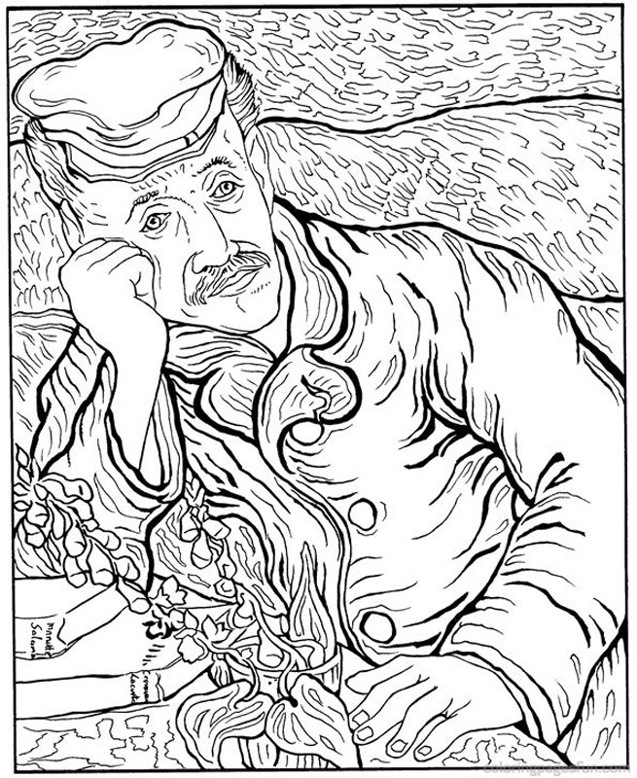
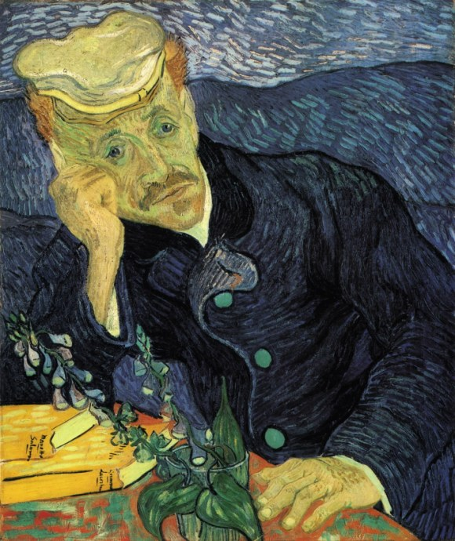
16 Squares Post-Production (4 points)
- Identify the artist, the name of the art work, date and location created :
a. Vincent Van Gough
b. Portrait of Doctor Gachet
c. June 1890 in Musée d'Orsay, Paris

- Describe the original image created by the artist.
It is a portrait of an older man who is expressing sadness. He is wearing a dark blue jacket with green buttons and a sandstone colored hat. He is leaning on his right arm on a painted table. The colors of the table stand out from the rest of the painting. On the table there is a glass with a plant that produces a cluster of small, bell-shaped, blue flowers. Next to the plant there are two orange books with yellow pages. The man appears to be outside in the evening air.

- Analyze describing the use of elements and principles in the artwork.
Contrast is present when looking at the colors from the background, to the face, and to the table. A triangular movement goes from the face to the plant and to the left hand and back to the face. He uses asymmetry to balance the portrait; face, table and books to hand, jacket, and hills. The cool colors from the jacket and background contrast with the colors in the skin, table, and plant.

- How well did you match the “16 squares” reference? Where do you need more practice?
Sample: Most of the shapes align correctly in the jacket, arm and background hills but in the face there are areas that are not right. For instance, the right eye is offset by about a quarter of an inch and the lips are a bit crooked and too small.

